**PART I:**

Three observable trends:  
-Temperatures tend to increases as you get closer to the equator.  
-Temperatures trend downward as you mover further from the equator.  
-Humidity, cloudiness, & wind speed do not have a notable trends or correlation when plotting by latitude

**PART II:**

Total locations:

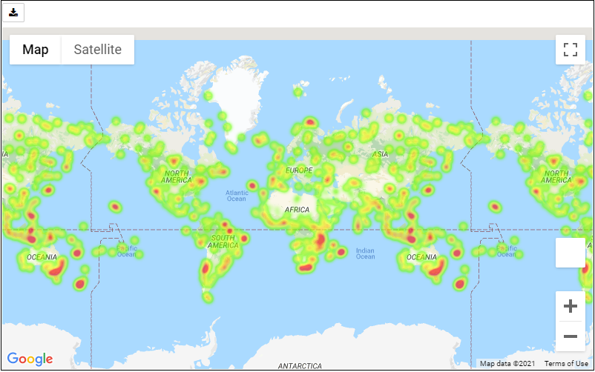

Filtered for ideal weather:

